SIMULATION EXPERIMENT – 4
Design and Comparative Analysis of Butterworth, Chebyshev and Elliptic IIR Filters Using MATLAB
Objectives of this Experiment:
1. To design Butterworth, Chebyshev Type-I and Elliptic IIR filters for comparable specifications.
2. To examine passband/stopband ripple, filter order and transition bandwidth for the three approximations.
3. To obtain and compare magnitude responses and filter orders.
4. To evaluate the trade-off between ripple, transition sharpness and filter complexity.
PROGRAM CODE:
clc;
clear;
close all;

%% 1. INPUT PARAMETERS
Fs = 1000; % Sampling frequency (Hz)
Fp = 100; % Passband edge (Hz)
Fst = 150; % Stopband edge (Hz)
Rp = 1; % Passband ripple (dB)
Rs = 40; % Stopband attenuation (dB)

% Normalized frequencies
Wp = Fp/(Fs/2);
Wst = Fst/(Fs/2);

%% 2. CHEBYSHEV TYPE-I FORMULA
epsilon = sqrt(10^(Rp/10)-1);
N_formula = acosh(sqrt((10^(Rs/10)-1)/(10^(Rp/10)-1))) / acosh(Fst/Fp);
N_theory = ceil(N_formula);

%% 3. BUTTERWORTH FILTER
[Nb,Wb] = buttord(Wp,Wst,Rp,Rs);
[bB,aB] = butter(Nb,Wb,'low');

%% 4. CHEBYSHEV TYPE-I FILTER
[Nc,Wc] = cheb1ord(Wp,Wst,Rp,Rs);
[bC,aC] = cheby1(Nc,Rp,Wc,'low');

%% 5. ELLIPTIC FILTER
[Ne,We] = ellipord(Wp,Wst,Rp,Rs);
[bE,aE] = ellip(Ne,Rp,Rs,We,'low');

%% 6. DISPLAY INPUT PARAMETERS
fprintf('\n====================================================\n');
fprintf(' IIR FILTER COMPARATIVE ANALYSIS\n');
fprintf('====================================================\n');
fprintf('\nINPUT PARAMETERS\n');
fprintf('Sampling Frequency = %.2f Hz\n',Fs);
fprintf('Passband Edge Frequency = %.2f Hz\n',Fp);
fprintf('Stopband Edge Frequency = %.2f Hz\n',Fst);
fprintf('Passband Ripple = %.2f dB\n',Rp);
fprintf('Stopband Attenuation = %.2f dB\n',Rs);

%% 7. CHEBYSHEV FORMULA RESULTS
fprintf('\nCHEBYSHEV TYPE-I FORMULA\n');
fprintf('Ripple factor epsilon = %.4f\n',epsilon);
fprintf('Calculated order = %.4f\n',N_formula);
fprintf('Theoretical minimum N = %d\n',N_theory);

%% 8. FILTER ORDER COMPARISON
fprintf('\n====================================================\n');
fprintf(' FILTER ORDER COMPARISON\n');
fprintf('====================================================\n');
fprintf('Butterworth Order = %d\n',Nb);
fprintf('Chebyshev Type-I Order = %d\n',Nc);
fprintf('Elliptic Order = %d\n',Ne);

%% 9. COEFFICIENTS
fprintf('\n====================================================\n');
fprintf(' BUTTERWORTH COEFFICIENTS\n');
fprintf('====================================================\n');
fprintf('Numerator b =\n'); disp(bB);
fprintf('Denominator a =\n'); disp(aB);

fprintf('\n====================================================\n');
fprintf(' CHEBYSHEV TYPE-I COEFFICIENTS\n');
fprintf('====================================================\n');
fprintf('Numerator b =\n'); disp(bC);
fprintf('Denominator a =\n'); disp(aC);

fprintf('\n====================================================\n');
fprintf(' ELLIPTIC COEFFICIENTS\n');
fprintf('====================================================\n');
fprintf('Numerator b =\n'); disp(bE);
fprintf('Denominator a =\n'); disp(aE);

%% 10. FREQUENCY RESPONSES
N = 4096;
[HB,f] = freqz(bB,aB,N,Fs);
[HC,~] = freqz(bC,aC,N,Fs);
[HE,~] = freqz(bE,aE,N,Fs);
MB = 20*log10(abs(HB)+eps);
MC = 20*log10(abs(HC)+eps);
ME = 20*log10(abs(HE)+eps);

%% 11. PASSBAND RIPPLE
P = f <= Fp;
Ripple_B = max(MB(P))-min(MB(P));
Ripple_C = max(MC(P))-min(MC(P));
Ripple_E = max(ME(P))-min(ME(P));

%% 12. STOPBAND ATTENUATION
S = f >= Fst;
Stop_B = -max(MB(S));
Stop_C = -max(MC(S));
Stop_E = -max(ME(S));

%% 13. PERCENTAGE DEVIATION
Dev_C_Ripple = abs(Ripple_C-Rp)/Rp*100;
Dev_B_Stop = abs(Stop_B-Rs)/Rs*100;
Dev_C_Stop = abs(Stop_C-Rs)/Rs*100;
Dev_E_Stop = abs(Stop_E-Rs)/Rs*100;

%% 14. TRANSITION CHARACTERISTICS
TransitionBW = Fst-Fp;

%% 15. DISPLAY PERFORMANCE
fprintf('\n====================================================\n');
fprintf(' FILTER PERFORMANCE\n');
fprintf('====================================================\n');
fprintf('\nPASSBAND RIPPLE\n');
fprintf('Butterworth = %.4f dB\n',Ripple_B);
fprintf('Chebyshev Type-I = %.4f dB\n',Ripple_C);
fprintf('Elliptic = %.4f dB\n',Ripple_E);
fprintf('\nSTOPBAND ATTENUATION\n');
fprintf('Butterworth = %.4f dB\n',Stop_B);
fprintf('Chebyshev Type-I = %.4f dB\n',Stop_C);
fprintf('Elliptic = %.4f dB\n',Stop_E);
fprintf('\nCHEBYSHEV RIPPLE DEVIATION\n');
fprintf('Specified Ripple = %.2f dB\n',Rp);
fprintf('Measured Ripple = %.4f dB\n',Ripple_C);
fprintf('Percentage Deviation = %.4f %%\n',Dev_C_Ripple);
fprintf('\nTRANSITION CHARACTERISTICS\n');
fprintf('Passband Edge = %.2f Hz\n',Fp);
fprintf('Stopband Edge = %.2f Hz\n',Fst);
fprintf('Transition Band = %.2f Hz\n',TransitionBW);

%% 16. MAGNITUDE RESPONSE
figure;
plot(f,MB,'LineWidth',1.5); hold on;
plot(f,MC,'LineWidth',1.5);
plot(f,ME,'LineWidth',1.5);
grid on;
xlabel('Frequency (Hz)'); ylabel('Magnitude (dB)');
title('Comparison of IIR Filter Magnitude Responses');
legend('Butterworth','Chebyshev Type-I','Elliptic');
xlim([0 250]); ylim([-80 5]);
xline(Fp,'--','Fp = 100 Hz');
xline(Fst,'--','Fst = 150 Hz');
yline(-Rp,'--','Rp = -1 dB');
yline(-Rs,'--','Rs = -40 dB');
hold off;

%% 17. PHASE RESPONSE
Phase_B = unwrap(angle(HB))*180/pi;
Phase_C = unwrap(angle(HC))*180/pi;
Phase_E = unwrap(angle(HE))*180/pi;
figure;
plot(f,Phase_B,'LineWidth',1.2); hold on;
plot(f,Phase_C,'LineWidth',1.2);
plot(f,Phase_E,'LineWidth',1.2);
grid on;
xlabel('Frequency (Hz)'); ylabel('Phase (degrees)');
title('Comparison of IIR Filter Phase Responses');
legend('Butterworth','Chebyshev Type-I','Elliptic');
xlim([0 250]);
hold off;

%% 18. FILTER ORDER GRAPH
figure;
bar([Nb Nc Ne]);
set(gca,'XTick',1:3);
set(gca,'XTickLabel',{'Butterworth','Chebyshev-I','Elliptic'});
ylabel('Filter Order'); xlabel('Filter Type');
title('Comparison of IIR Filter Orders');
grid on;
OUTPUT:
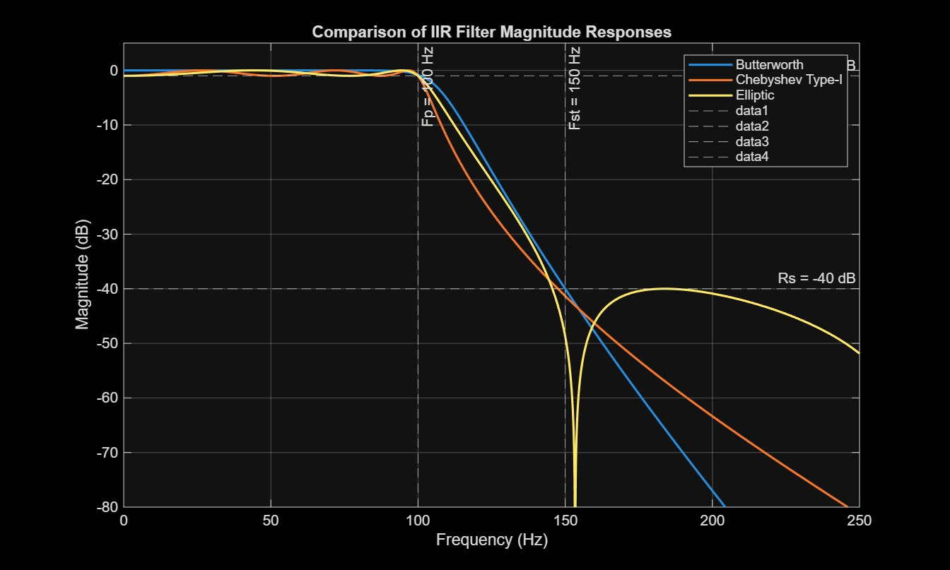
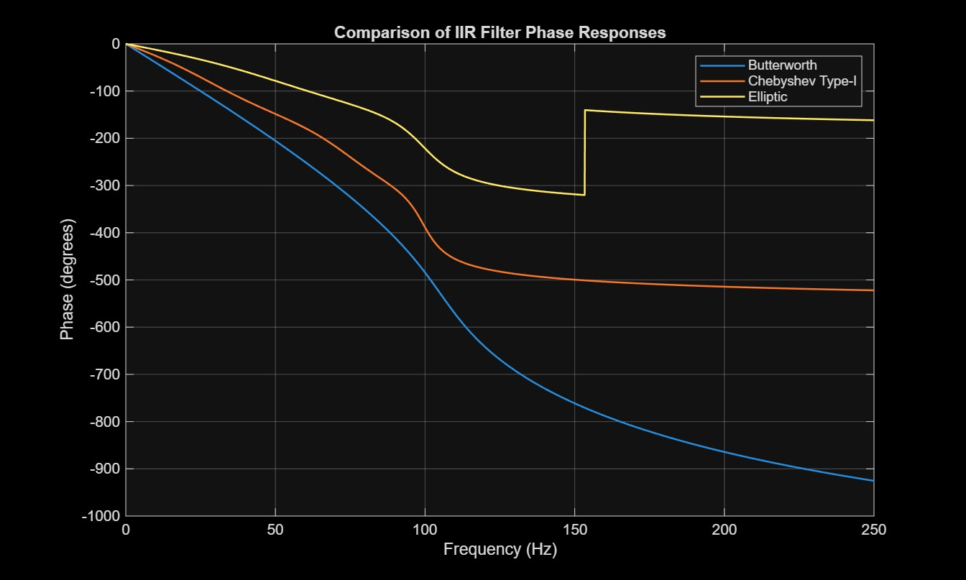
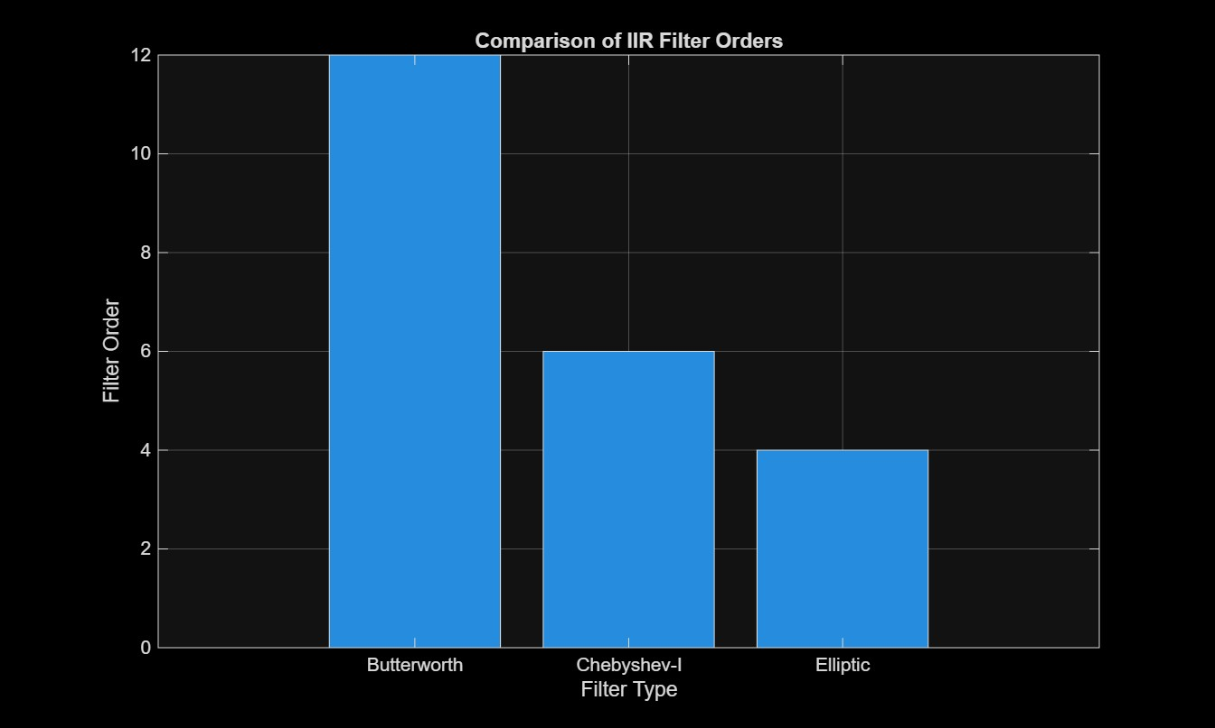
RESULT:

====================================================
IIR FILTER COMPARATIVE ANALYSIS
====================================================

INPUT PARAMETERS
Sampling Frequency = 1000.00 Hz
Passband Edge Frequency = 100.00 Hz
Stopband Edge Frequency = 150.00 Hz
Passband Ripple = 1.00 dB
Stopband Attenuation = 40.00 dB

CHEBYSHEV TYPE-I FORMULA
Ripple factor epsilon = 0.5088
Calculated order = 6.2071
Theoretical minimum N = 7

====================================================
FILTER ORDER COMPARISON
====================================================
Butterworth Order = 12
Chebyshev Type-I Order = 6
Elliptic Order = 4

====================================================
BUTTERWORTH COEFFICIENTS
====================================================
Numerator b =
1.0e-03 *

0.0002 0.0027 0.0146 0.0488 0.1098 0.1757 0.2050 0.1757 0.1098 0.0488 0.0146 0.0027 0.0002

Denominator a =
1.0000 -6.8844 22.4341 -45.5100 63.7725 -64.8501 48.9643 -27.6092 11.5218 -3.4662 0.7128 -0.0899 0.0053

====================================================
CHEBYSHEV TYPE-I COEFFICIENTS
====================================================
Numerator b =
1.0e-03 *

0.0464 0.2782 0.6956 0.9274 0.6956 0.2782 0.0464

Denominator a =
1.0000 -4.8694 10.3807 -12.3367 8.5969 -3.3268 0.5586

====================================================
ELLIPTIC COEFFICIENTS
====================================================
Numerator b =
0.0197 -0.0171 0.0333 -0.0171 0.0197

Denominator a =
1.0000 -3.0330 3.8118 -2.2911 0.5554

====================================================
FILTER PERFORMANCE
====================================================

PASSBAND RIPPLE
Butterworth = 0.8033 dB
Chebyshev Type-I = 1.0000 dB
Elliptic = 1.0000 dB

STOPBAND ATTENUATION
Butterworth = 40.0198 dB
Chebyshev Type-I = 41.3365 dB
Elliptic = 40.0000 dB

CHEBYSHEV RIPPLE DEVIATION
Specified Ripple = 1.00 dB
Measured Ripple = 1.0000 dB
Percentage Deviation = 0.0000 %

TRANSITION CHARACTERISTICS
Passband Edge = 100.00 Hz
Stopband Edge = 150.00 Hz
Transition Band = 50.00 Hz
>>

